Question 10.
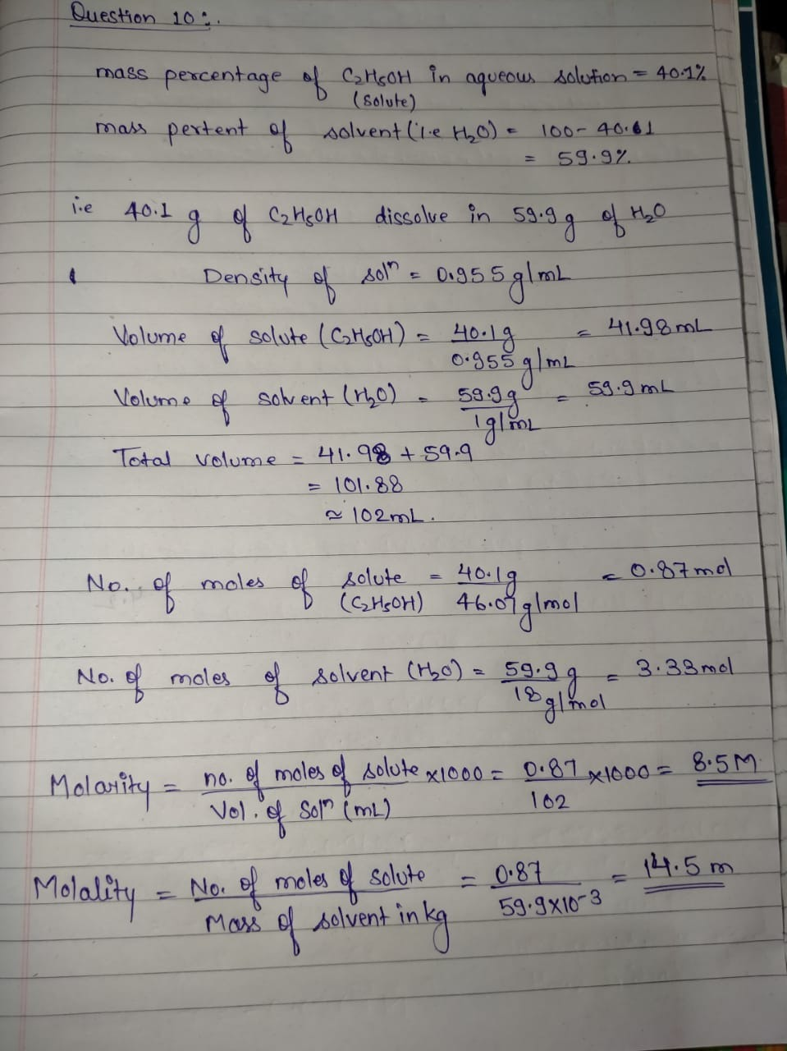
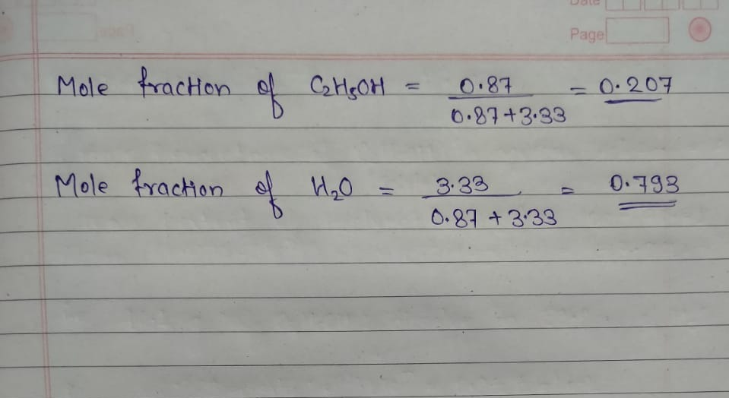

Q11

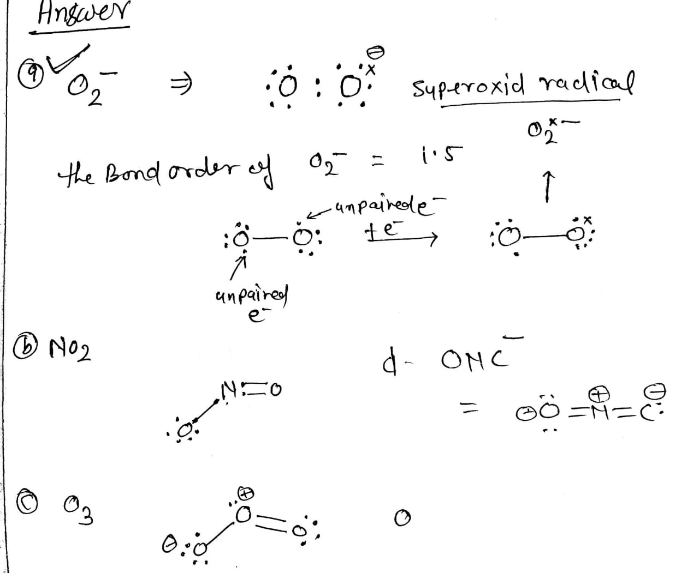
11b. the smallest bond angle for IF3 is 90° which is smaller than the NF3 in which bond angle is 107° and which is again smaller than the BF3 in which the bond angle is 120°

